Day 3 Assignmentm

1.For the given JSON iterate over all for loops (for, for in, for of, forEach)

Ans:

// json to be iterated

const object = {

name:"kaushik",

college:"Banglore institue of technology",

rollno: 47,

branch:"Civil Engineering"

}

// iterating using for in

for (let property in object) {

console.log(`${property}: ${object[property]}`);

}

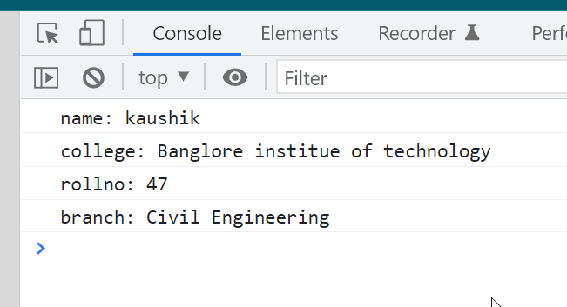

// iterating using for

for(let i=0;i<2;i++)

{console.log(`Name : ${object.name},

college: ${object.college},

roll no : ${object.rollno},

branch : ${object.branch} `)

}



// iterating using for of

for (const [key, value] of Object.entries(object)) {

console.log(`${key}: ${value}`);

}



// iterating using for each loop

Object.keys(object).forEach(function(key) {

console.log(key, object[key]);

});



2.Create your own resume data in JSON format

Ans;

// my resume using json

let resume={

"intro": {

"name": "Kaushik Bhat",

"email": "kaushikgb99@gmail.com",

"phone": 9110691605,

"degree": "B-tech(Civil Engineering",

"summary": "To Secure a responsible career oppurtinty to fully utilize my training and skills,while making significant contribution to the success of the organisation",

"location": {

"address": "Kannika mahal -J P Nagar",

"postalCode":560078,

"city": "Bangalore",

"country":"India",

"State": "Karnataka"

},

"profiles": [

{

"network": "A social media or other profile that you would like to include (e.g. LinkedIn, Twitter)",

"username": "Your username on this network",

"url": "A URL to your user profile page"

}

]

},

"education": [

{

"institution": "Bangalore Institute of Technology",

"Branch": "Civil Engineering",

"startDate": "1-8-2017",

"endDate": "1-7-2021",

"gpa": "7.5",

}

],

"skills": [

{

"name": "programming languages",

"level": "basic",

}

],

"languages": [

{

"language": "English",

"fluency": "professional fluency"

}

],

"interests": [

{

"name": "music"

}

]

}

console.log(resume);

